INTI International College Penang School of Engineering and Technology

3+0 Bachelor of Science (Hons) in Computer Science, in collaboration with Coventry University, UK

3+0 Bachelor of Science (Hons) in Computing, in collaboration with Coventry University, UK

Coursework cover sheet

Section A - To be completed by the student

Full Name:
Chin Guan Xue
CU Student ID Number:
13446916
Semester:
1
Lecturer: Mr. Lau Teng Lye, Light

Module Code and Title: 4005CEM/ Database Systems

Assignment No. / Title: Assignment 1 | 100% of Module Mark
Hand out date:  Week 2 of August 2022 session | Due date:  Week 15 of August 2022 session

Section B - To be completed by the module leader

Intended learning outcomes assessed by this work:
- Understand the sources of data in society, how to collect such data, the problems that might occur in collecting and storing such data and the basic statistics that are routinely performed on it.
- Model databases using techniques such as normalisation, entity relationship diagrams or a document-based approach.
- Create, populate and perform basic access approaches on a database using SQL Database Management System (DBMS)
- Analyse different types of data using tools.

Marking scheme (Refer to the assignment rubrics) | Max | Mark
Task  - Individual Report | 100
Total | 100
Lecturer’s Feedback

Internal Moderator’s Feedback

  - Background
Online Shopping System is the topic that I had chosen to make a survey and collect the data as for study purposes . And the company that being chose is the Shop.com which is a online shopping website that held and controlled by Market America .Market America is a multilevel marketing company being held by JR and Loren ridinger in 1992 .The headquarters are in GreensBoro ,North Carolina and this company yield by about 800 workers inside . But once due to the pandemic of COVID-19 , the website is started to spread all across the world and also included Malaysia as well . This website have a bit difference between others company such as Shopee and Lazada because it had cooperation to many company such as Nike , Adidas and all those famous branded goods. This bring the benefits that buyers or customers able to get their things directly from the company not passing through an agent . In details , the quality of the product can be always secured .
  - Workflow
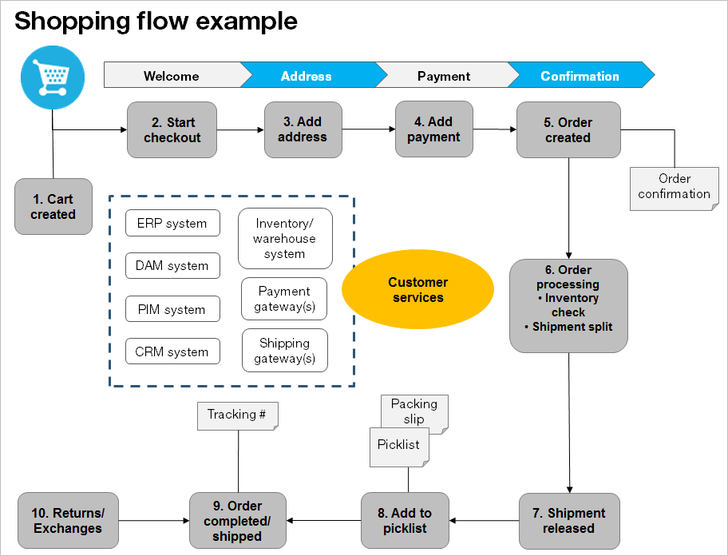
As diagram above shown , the work flow start by a customer clicking the order now button , then system will calculate the total of the fees including using vouchers or any other membership discount . Then , customer will be asked to add address into the database to save for onward usage . Then is about the payment method , online banking , e-Wallet and also the Cash On delivery method is also included here . After payment success, An order will be created , as for customer , they will receive a receipt to check their order . As for the seller , they need to packed the order and send to a shipment company such as J&T Express and also LALAMOVE . After the order being completed , then the money will be paid to the seller company.

  - Data collection method
In order to make a survey online , Google Form is on of the best online template for students because it is free . Below shows the questionnaire of the survey that had been done and collected 20 data from students in INTI International College Penang .
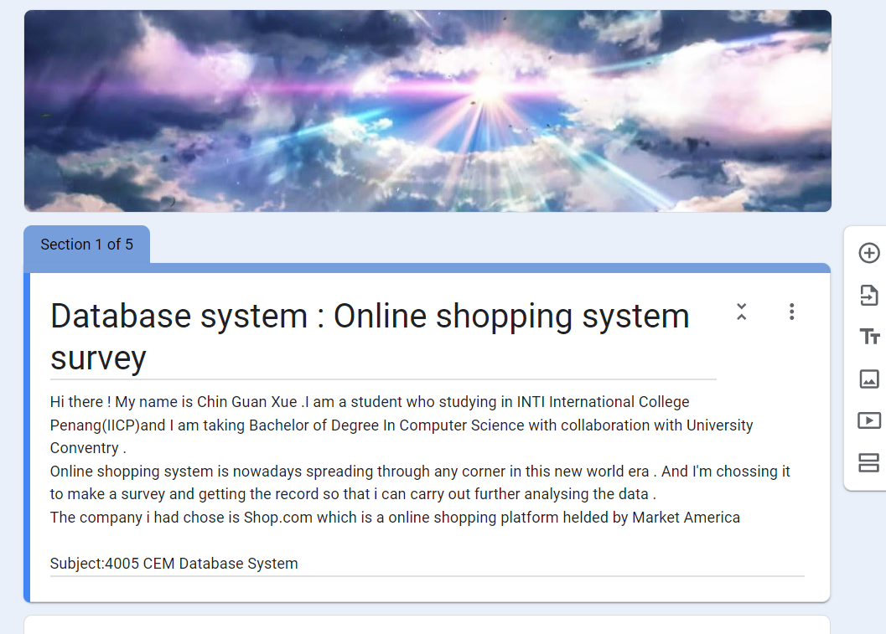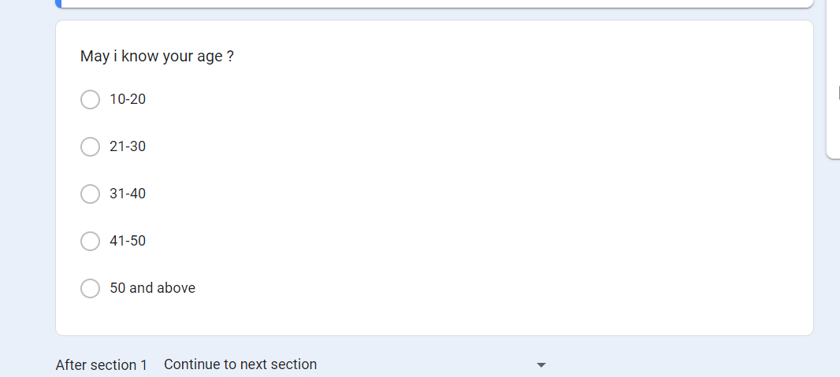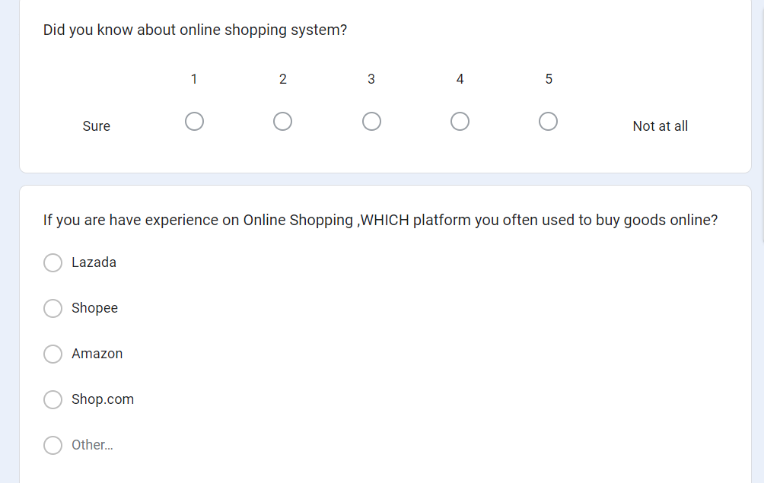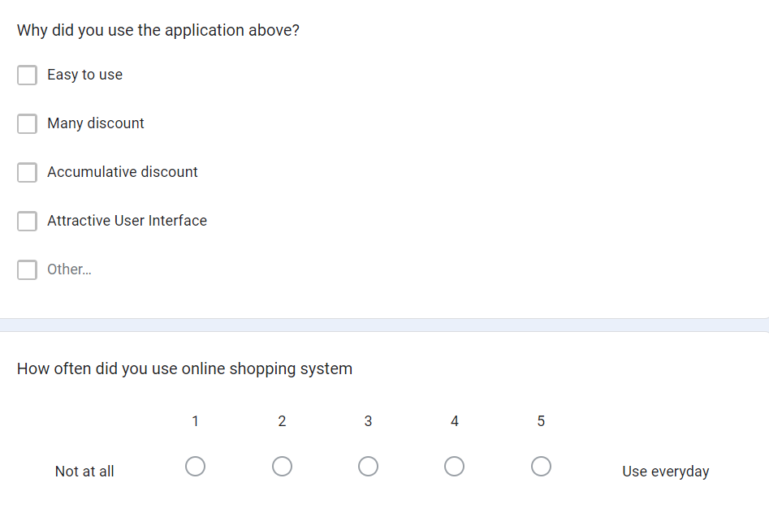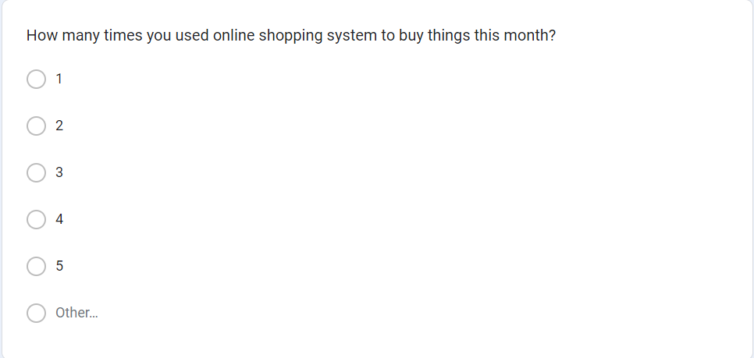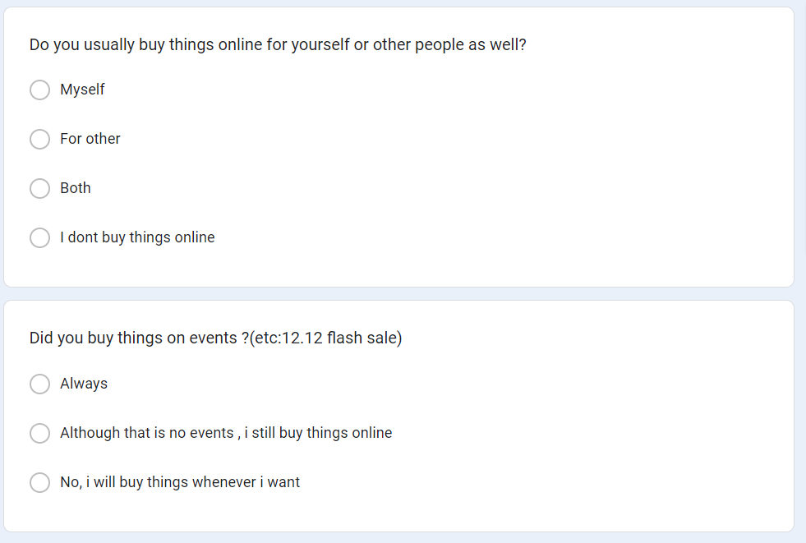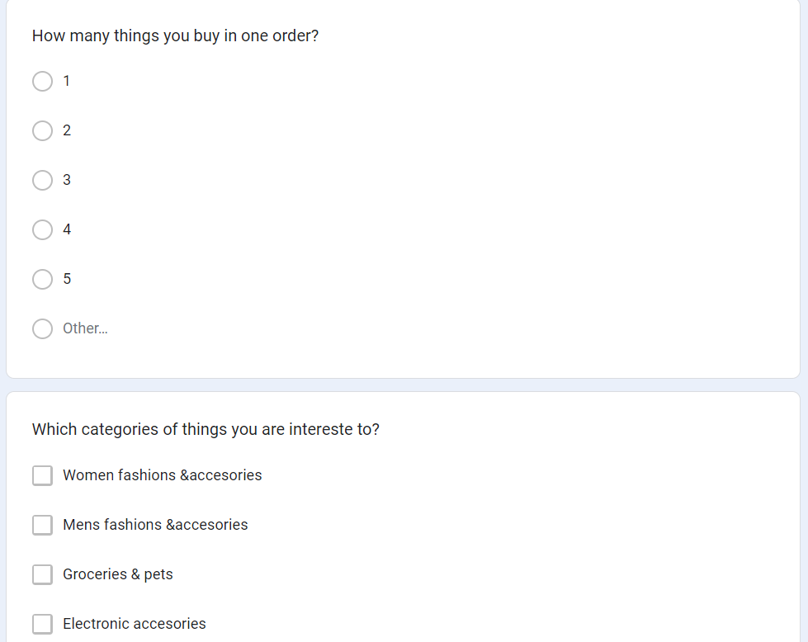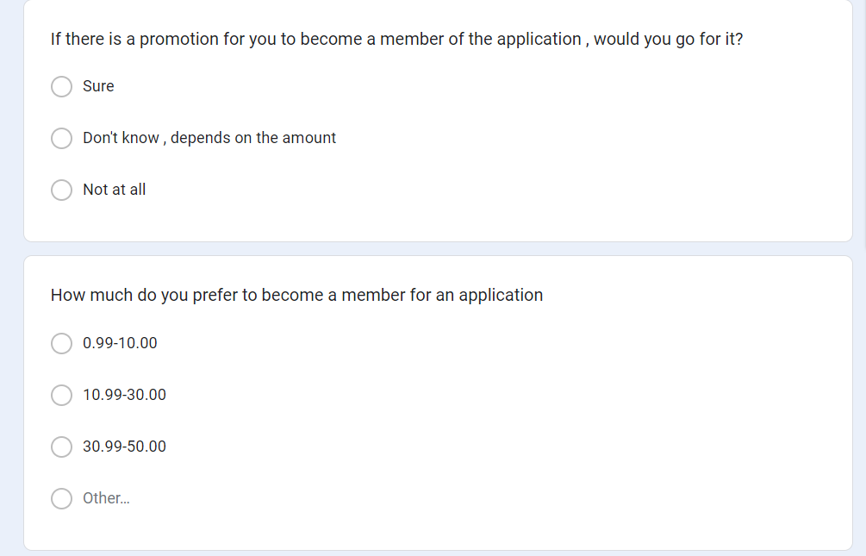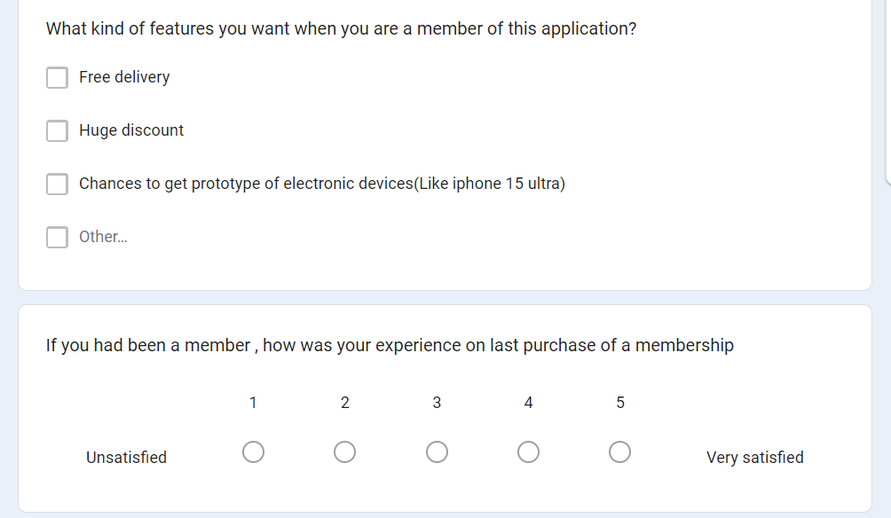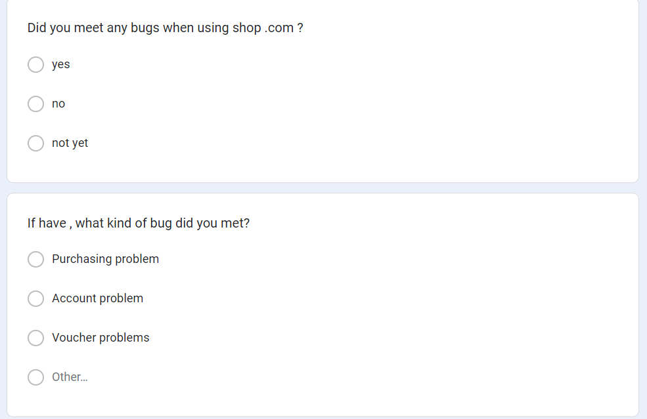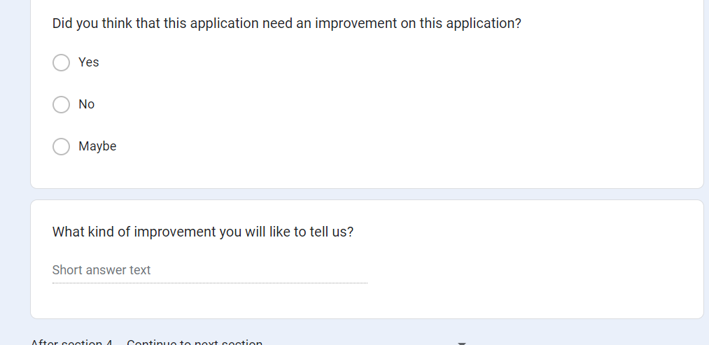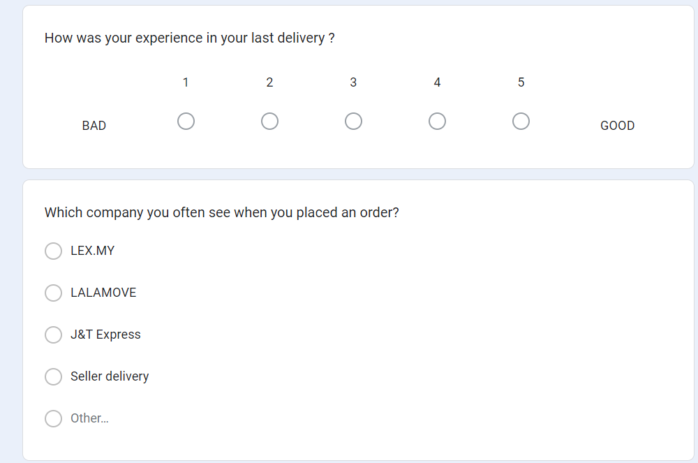

Above is the questionnaire for students .

2.0 ERD diagram
Below diagram shows the ERD diagram of the system .
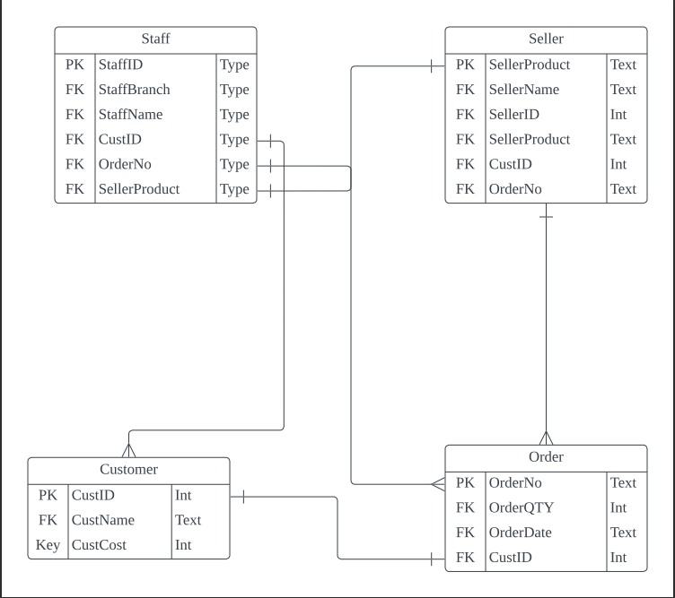

2.1 Data Normalisation
Diagram below show the data normalisation that had been categorized into three normal from which is 1NF, 2NF and 3NF.
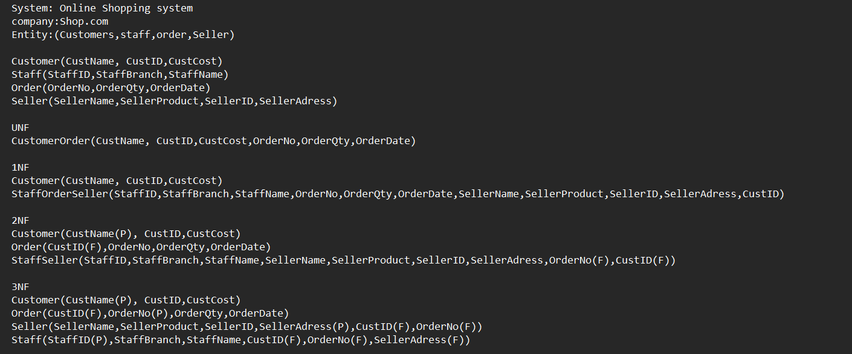

3.1Data Validation
Firstly is about the data type , when an string value is inserted into a integer column , below error will be popped out.
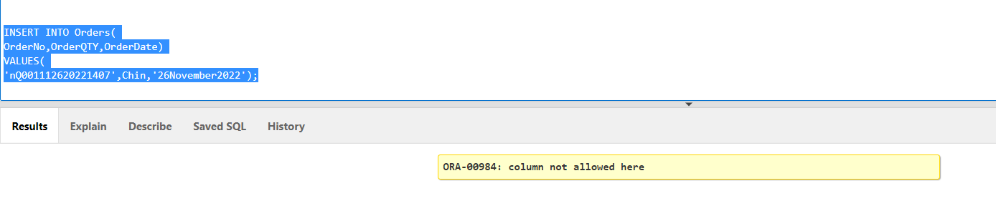

As for the primary key , one table can only have one primary key .If altering table and set another foreign key to a primary key , belows error will be shown.

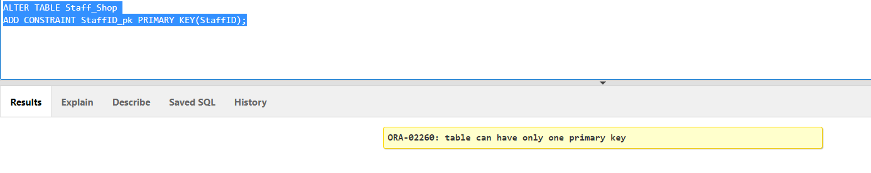

4.1 Data analysis

To analyse the raw data from the google forms ,we had turned it into a weka file .
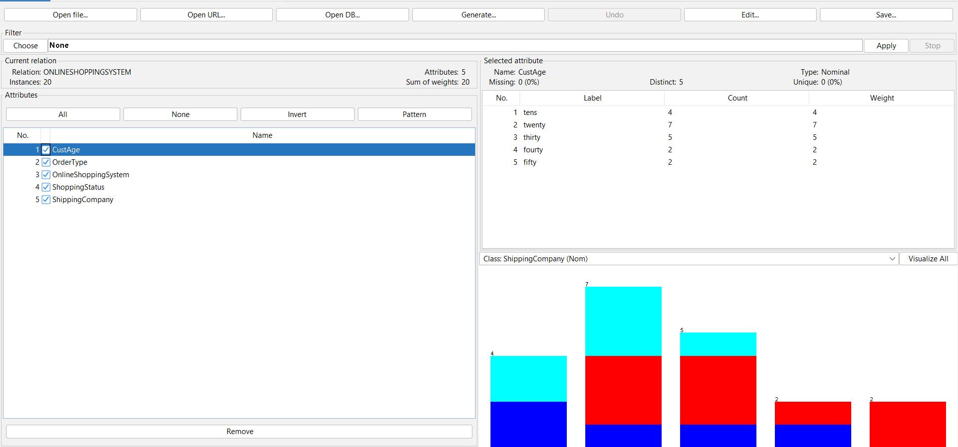

To insert the data , we used the wordpad to apply changes to the table as shown as below.
For the OrderType, G means Groceries , MA means Men’s Fashion and Accessories , WA means Women Fashion and accessories , and EA means Electronic Accessories.
